CENWP-OD-B
15 June 2009
MEMORANDUM FOR THE RECORD

SUBJECT: Dead chinook at Bonneville’s Adult Fish Facility (AFF).

On 15 June at approximately 1400, CRITFC reported a dead clipped adult chinook in the AFF to Project Fisheries. The fish appeared to be in good condition with no obvious cause of death. CRITFC had sampled and tagged the fish, and released it into the brail pool to recover. When CRITFC noticed the fish was not recovering in the brail pool, they placed it in the small recovery tank, but it did not recover. Information they provided is below.

- Species – Chinook, female
- Origin – hatchery, clipped
- Length – 83.5 cm
- Weight – Unknown
- Marks and Injuries noted during tagging- Old sea lion wounds
- Marks and Injuries found on the carcass– none
- Cause and Time of Death – Unknown
- Future and Preventative Measures – NA
- Other – PIT tag #3D9.1C2D07F02F.

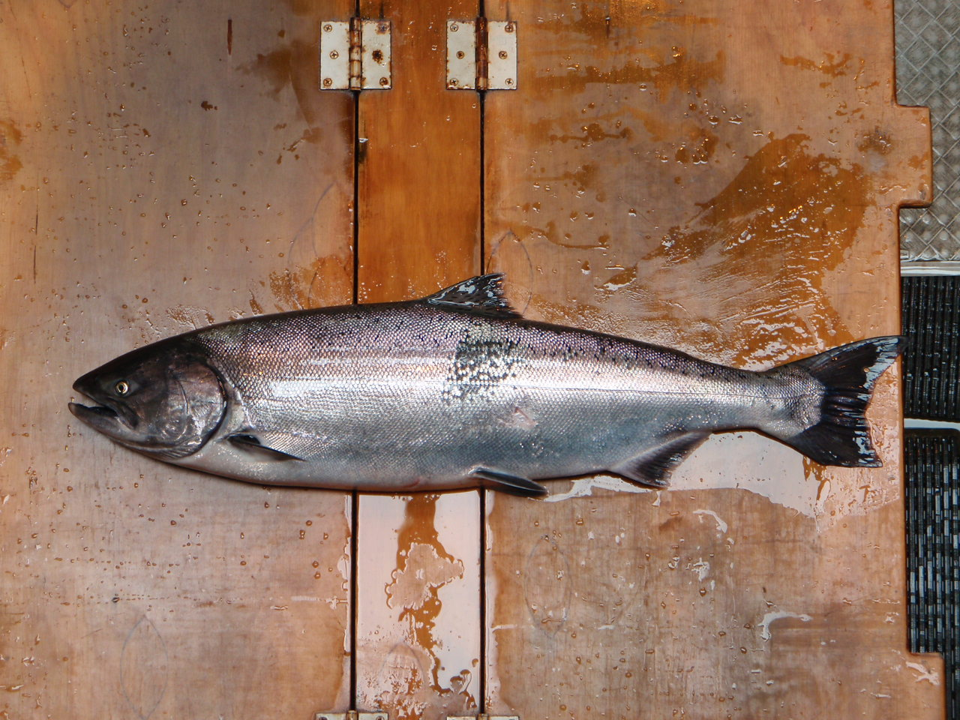

Bonneville Fisheries

